Forklift Hook Forklift Accessories
Factory direct sales can customize various models

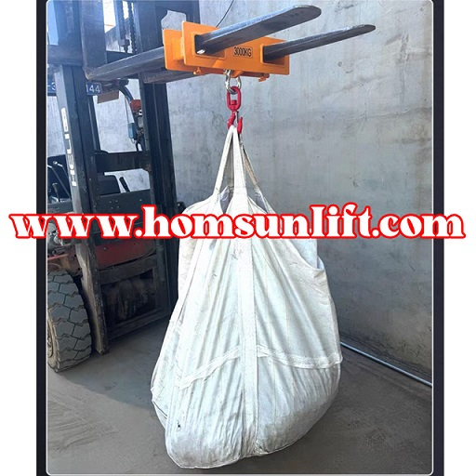

Hook lifting | conduct oneself with dignity | Inner diameter (long) | Inner diameter width
1 ton | 7kg | 150mm | 60mm
2 tons | 12.8kg | 152mm | 73mm
3 tons | 18kg | 150mm | 60mm
5 tons | 22.5kg | 190mm | 80mm
10 tons | 50kg | 190mm | 80mm

*Homsun Machinery Equipment Co., Ltd is a professional manufacture specializing in the R &D and producing of electric scissor lift , electric forklift, mobile yard ramp and motorised pallet truck high-quality hardware accessories. Established in 2016, we have over ten years of experience in the industry, dedicated to providing comprehensive solutions of carrying and lifting for all different industries.

*We are the source manufacturer and can also customize various types of forklifts according to customer needs.

*If needed, you can consult customer service.

Official website:https://www.homsunlift.com
WhatsApp/Wechat ID:+8613680275183
Email:sandy519@foxmail.com

