Heavy duty forklift fork clamp can be used for both fork and cargo clamping

Factory direct sales can customize various models

model | Installation Class | Fork length A  mm | Frame width B  mm | Arm extension range  mm | total height H  mm | bearing capacity  kg | Suitable for forklifts  t
CYSCZ2A20 | Ⅱ | 1220 | 940 | 410-1600 | 660 | 1600 | 1.5-2.5
CYSCZ3A30 | Ⅲ | 1220 | 1015 | 465-1810 | 725 | 2300 | 3.0-3.5

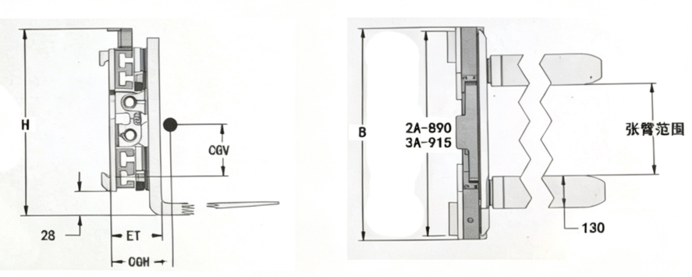

*****************************************************************************
The meaning of accessory installation level
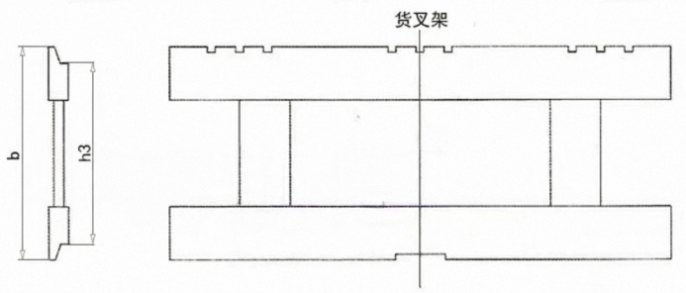

Installation level | Ⅱ | Ⅲ | Ⅳ | Ⅴ
Rated lifting capacity of forklift (kg) | 1000-2500 | 2501-4999 | 5000-8000 | 8001-10999

*Homsun Machinery Equipment Co., Ltd is a professional manufacture specializing in the R &D and producing of electric scissor lift , electric forklift, mobile yard ramp and motorised pallet truck high-quality hardware accessories. Established in 2016, we have over ten years of experience in the industry, dedicated to providing comprehensive solutions of carrying and lifting for all different industries.

*We are the source manufacturer and can also customize various types of forklifts according to customer needs.

*If needed, you can consult customer service.

Official website:https://www.homsunlift.com
WhatsApp/Wechat ID:+8613680275183
Email:sandy519@foxmail.com

Related product recommendations：
Lithium Battery Counterbalanced Forklift
Widened Fork Carriage
Dual cylinder Waste clamp
waste paper clip
Side shifter belt for forklift

