Manual pallet handling vehicle wheel assembly
Factory direct sales can customize various models

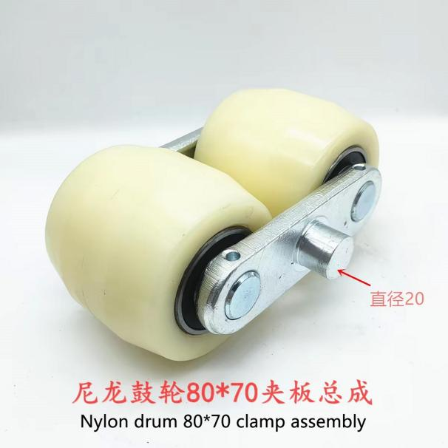
Nylon drum 80*70 clamp assembly
*********************************************************************
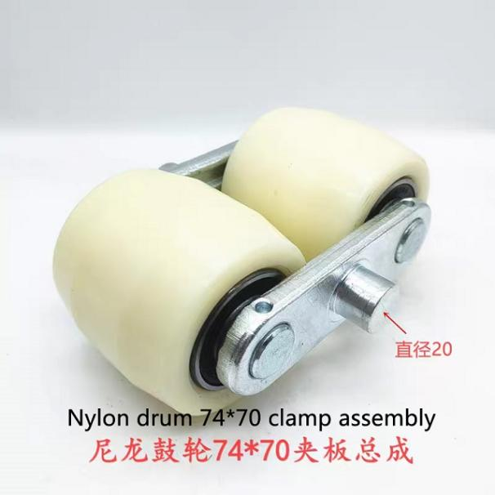
Nylon drum 74*70 clamp assembly
*********************************************************************
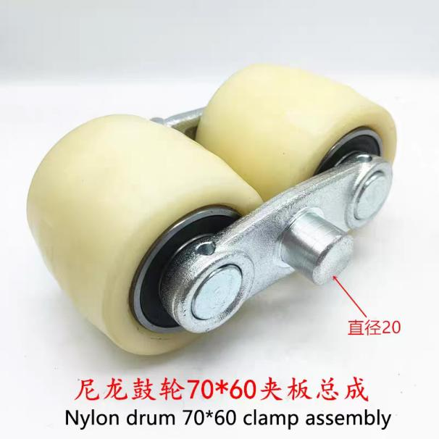
Nylon drum 70*60 clamp assembly
*********************************************************************
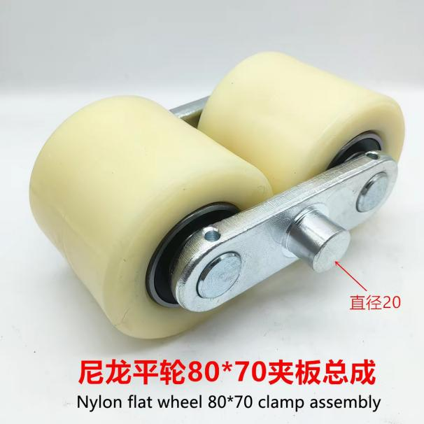
Nylon flat wheel 80*70 clamp assembly
*********************************************************************
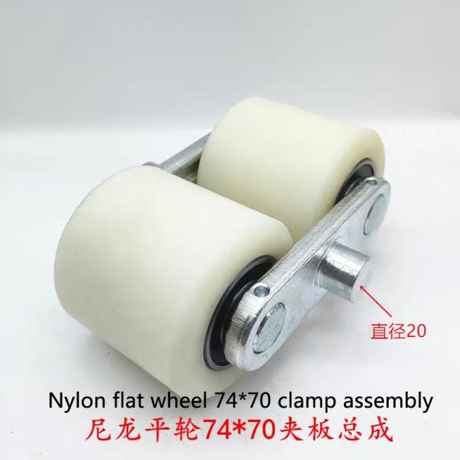
Nylon flat wheel 74*70 clamp assembly
*********************************************************************
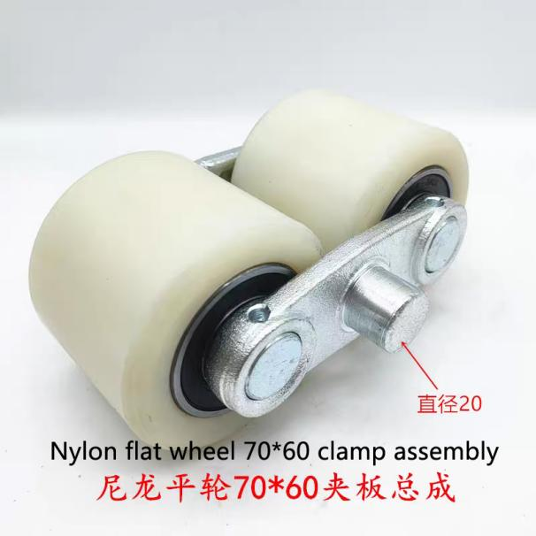
Nylon flat wheel 70*60 clamp assembly
*********************************************************************
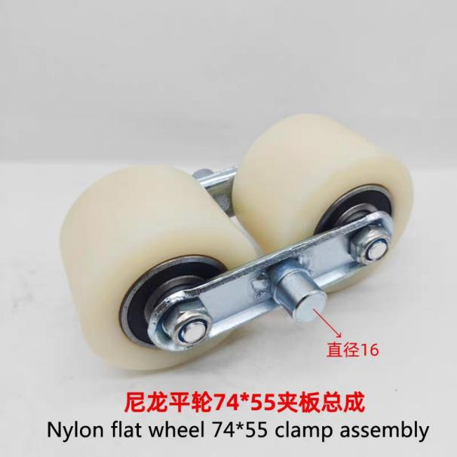
Nylon flat wheel 74*55 clamp assembly
*********************************************************************

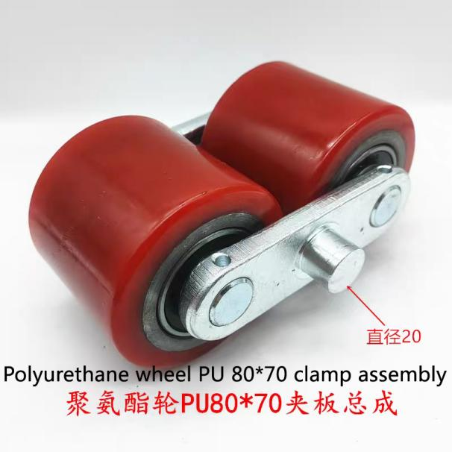
Polyurethane wheel PU 80*70 clamp assembly
*********************************************************************
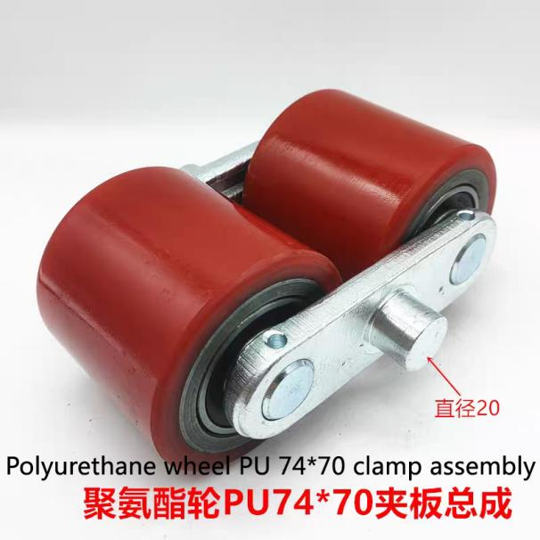
Polyurethane wheel PU 74*70 clamp assembly
*********************************************************************
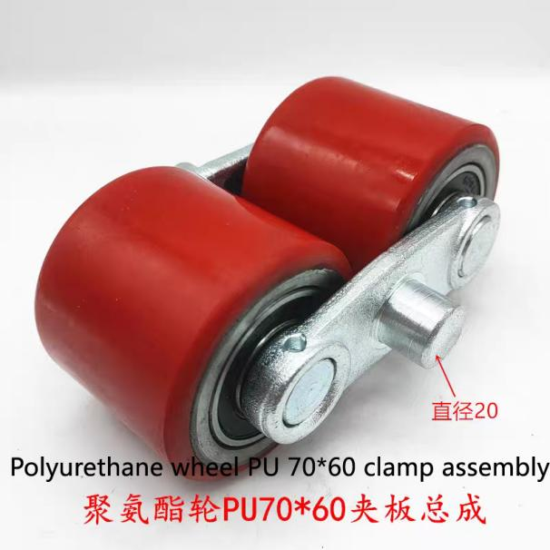
Polyurethane wheel PU 70*60 clamp assembly
*********************************************************************
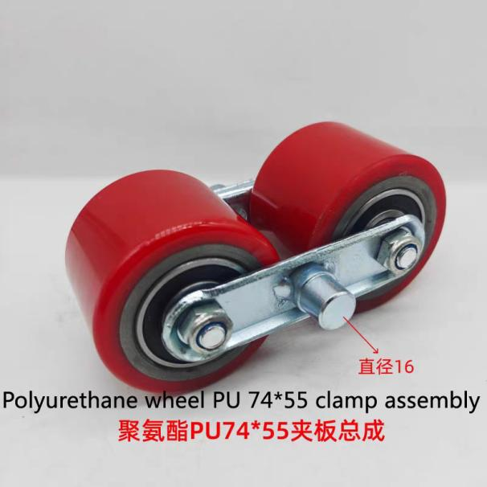
Polyurethane wheel PU 74*55 clamp assembly
*********************************************************************

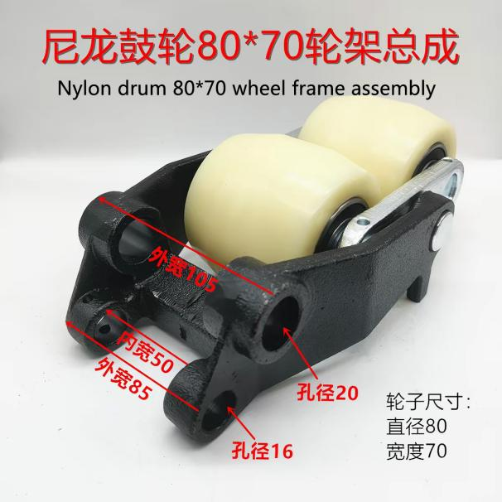
Nylon drum 80*70 wheel frame assembly
*********************************************************************
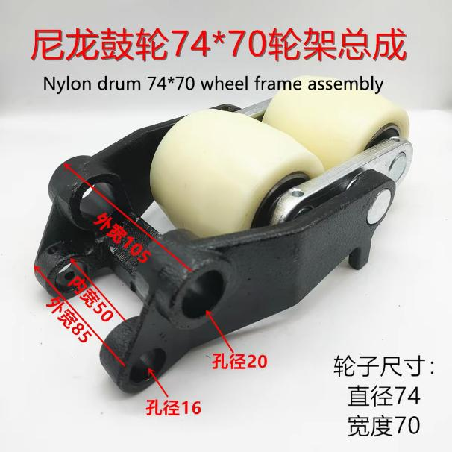
Nylon drum 74*70 wheel frame assembly
*********************************************************************
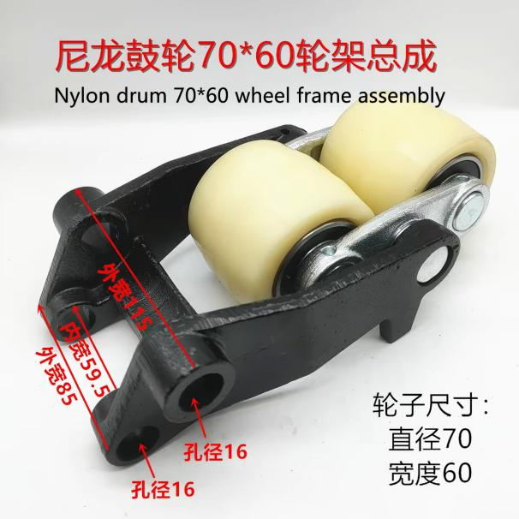
Nylon drum 70*60 wheel frame assembly
*********************************************************************

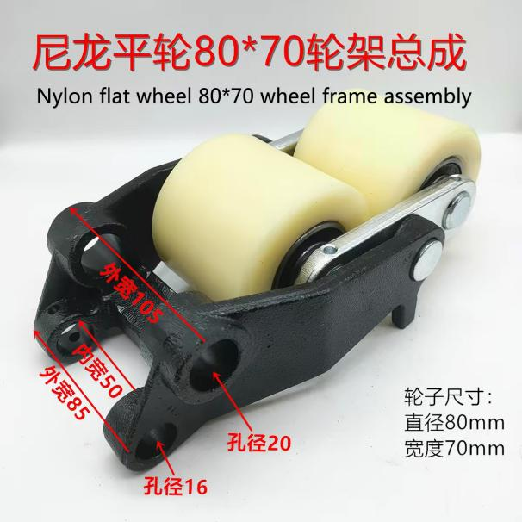
Nylon flat wheel 80*70 wheel frame assembly
*********************************************************************
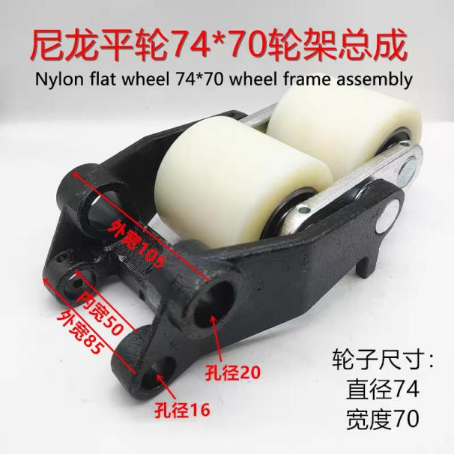
Nylon flat wheel 74*70 wheel frame assembly
*********************************************************************
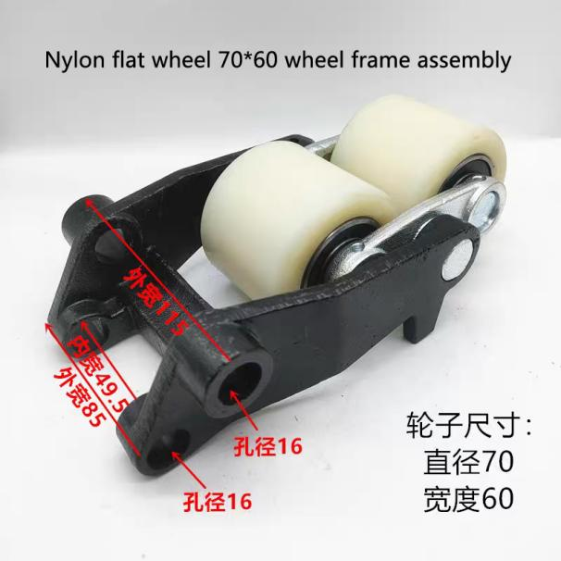
Nylon flat wheel 70*60 wheel frame assembly
*********************************************************************
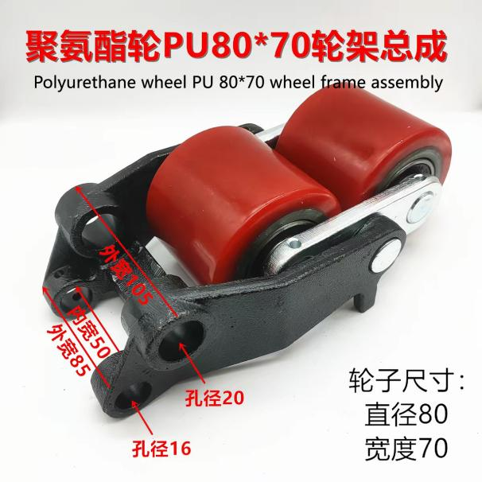
Polyurethane wheel PU 80*70 wheel frame assembly
*********************************************************************
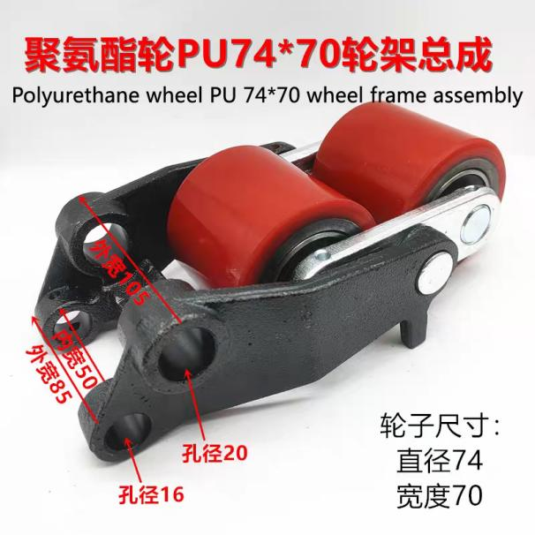
Polyurethane wheel PU 74*70 wheel frame assembly
*********************************************************************
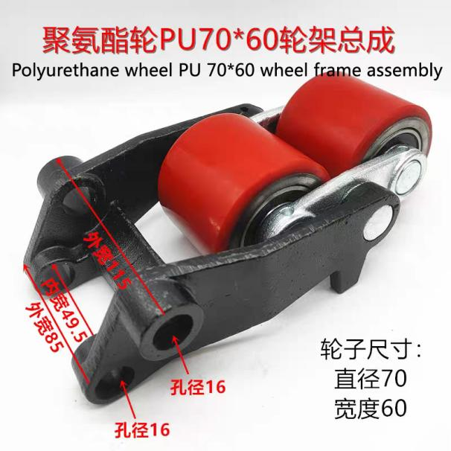
Polyurethane wheel PU 70*60 wheel frame assembly
*********************************************************************

*Homsun Machinery Equipment Co., Ltd is a professional manufacture specializing in the R &D and producing of electric scissor lift , electric forklift, mobile yard ramp and pallet jack high-quality hardware accessories. Established in 2016, we have over ten years of experience in the industry, dedicated to providing comprehensive solutions of carrying and lifting for all different industries.

*We are the source manufacturer and can also customize various types of forklifts according to customer needs.

*If needed, you can consult customer service.

Official website:https://www.homsunlift.com
WhatsApp/Wechat ID:+8613680275183
Email:sandy519@foxmail.com

Related product recommendations：
Manual Forklift Wheels
nylon Pu wheels
Stainless Steel pallet truck
manual pallet truck with scale
Manual Pallet Truck

