Forklift Steel Wheel
Factory direct sales can customize various models

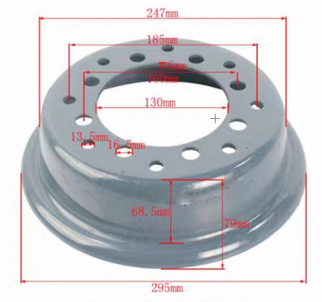

product name ： | Forklift Steel Wheel
size of product ： | 650-10 | installation size ： | 130×160 / 8 holes

*******************************************************************************
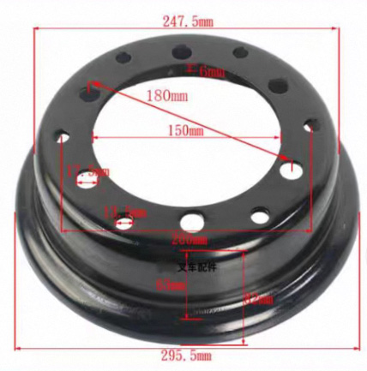
product name ： | Forklift Steel Wheel
size of product ： | 650-10 | installation size ： | 150×180 / 6 holes

*******************************************************************************

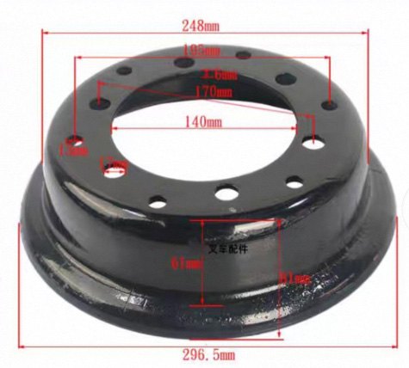
product name ： | Forklift Steel Wheel
size of product ： | 650-10 | installation size ： | 140×170 / 6 holes

*******************************************************************************

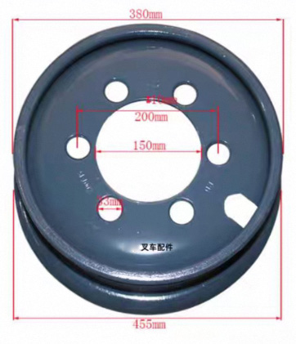
product name ： | Forklift Steel Wheel
size of product ： | 28*9-15 | installation size ： | 150×200 / 6 holes

*******************************************************************************

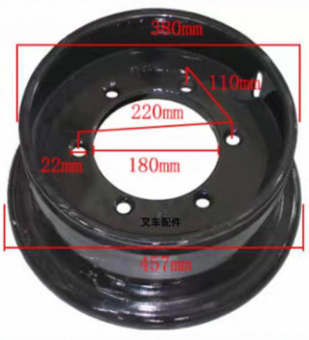

product name ： | Forklift Steel Wheel
size of product ： | 28*9-15 | installation size ： | 180×220 / 6 holes

*******************************************************************************

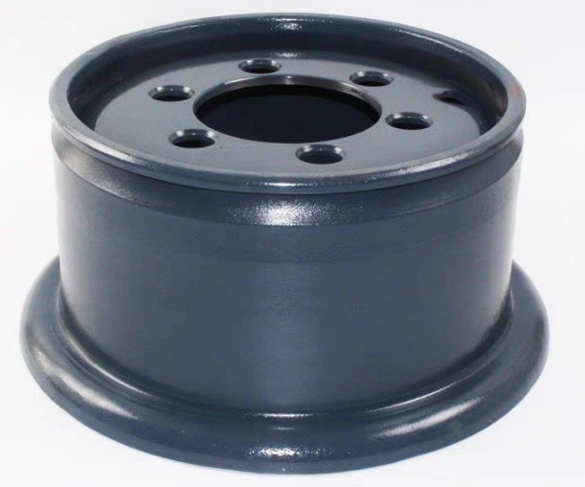
product name ： | Forklift Steel Wheel
size of product ： | 28*9-15 | installation size ： | 150×200 / 6 holes

*******************************************************************************
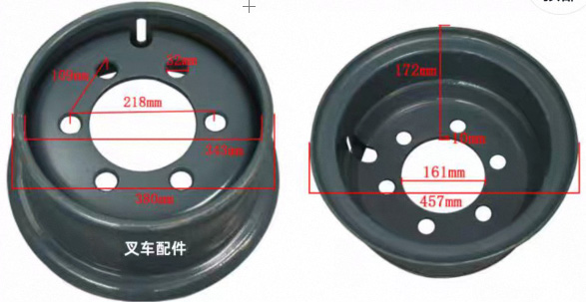

product name ： | Forklift Steel Wheel
size of product ： | 28*9-15 | installation size ： | 161×218 / 6 holes

*******************************************************************************
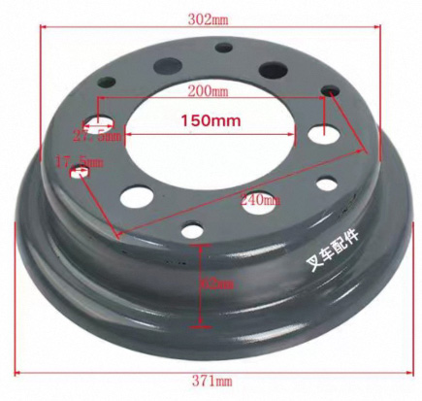

product name ： | Forklift Steel Wheel
size of product ： | 700-12 | installation size ： | 150×200 / 6 holes

*******************************************************************************

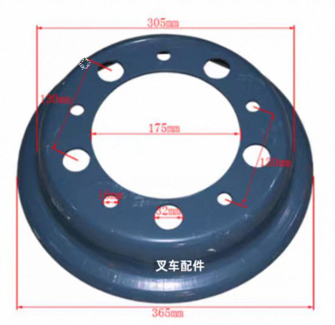

product name ： | Forklift Steel Wheel
size of product ： | 700-12 | installation size ： | 175×220 / 8 holes

*******************************************************************************
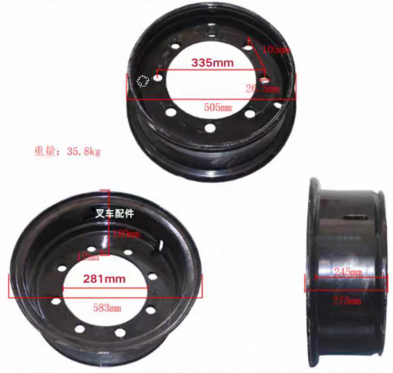
product name ： | Forklift Steel Wheel
size of product ： | 900-20 | installation size ： | 281×335 / 8-hole

*******************************************************************************

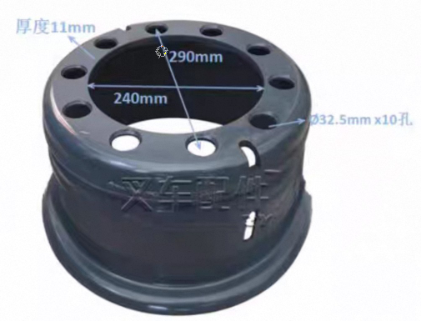

product name ： | Forklift Steel Wheel
size of product ： | 825-15 | installation size ： | 240×290 / 10 holes

*******************************************************************************

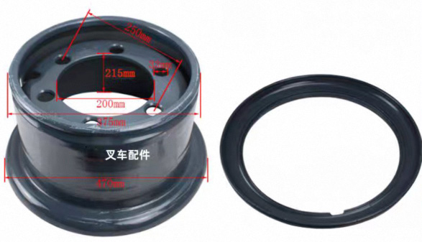
product name ： | Forklift Steel Wheel
size of product ： | 300-15 | installation size ： | 200×250 / 6-hole

*******************************************************************************

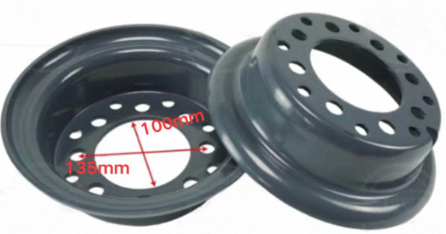

product name ： | Forklift Steel Wheel
size of product ： | 18*7-8 | installation size ： | 100×135 / 8-hole

*******************************************************************************

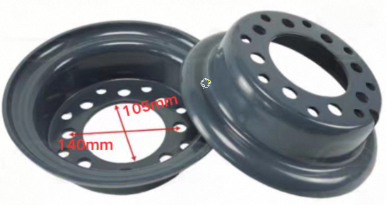

product name ： | Forklift Steel Wheel
size of product ： | 18*7-8 | installation size ： | 105×140 / 8-hole

Note:
If you need steel ring fixing screws, please consult customer service.

*Homsun Machinery Equipment Co., Ltd is a professional manufacture specializing in the R &D and producing of electric scissor lift , electric forklift, mobile yard ramp and motorised pallet truck high-quality hardware accessories. Established in 2016, we have over ten years of experience in the industry, dedicated to providing comprehensive solutions of carrying and lifting for all different industries.

*We are the source manufacturer and can also customize various types of forklifts according to customer needs.

*If needed, you can consult customer service.

Official website:https://www.homsunlift.com
WhatsApp/Wechat ID:+8613680275183
Email:sandy519@foxmail.com

Related product recommendations：
forklift Tires
Manual Hydraulic Forklift Wheels
oil bucket clamp
Forklift Oil Drum Clamp

