Forklift cotton clip, flat grip clip, waste paper bag clip
Factory direct sales can customize various models

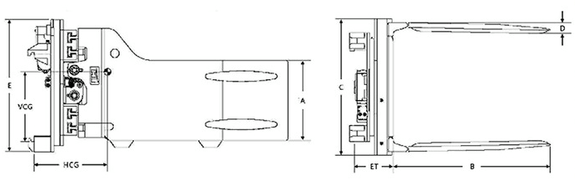

Rotary soft-clamp
model | carrying capacity @  load center  (kg@mm) | Installation Class  ISO | Shoulder range of motion  ITI  (mm) | brachium L  (mm) | Arm height  C  (mm) | Arm thickness  T  (mm) | width  B  (mm) | altitude  H  (mm) | Vertical center of gravity  VCG  (mm) | Loss of load capacity  ET  (mm) | Horizontal center of gravity  HCG  (mm) | conduct oneself with dignity  (kg)
BCR-20D-01B | 1900@500 | II | 450-1730 | 991 | 415 | 70 | 1040 | 775 | 335 | 221 | 300 | 640
BCR-20D-01C | 1900@500 | III | 450-1730 | 991 | 415 | 70 | 1040 | 775 | 335 | 221 | 300 | 640
BCR-20D-02B | 1900@500 | II | 440-1730 | 1194 | 415 | 70 | 1040 | 775 | 335 | 221 | 368 | 683
BCR-20D-02C | 1900@500 | III | 440-1730 | 1194 | 415 | 70 | 1040 | 775 | 335 | 221 | 368 | 683
BCR-30D-01B | 2700@500 | II | 550-1900 | 991 | 460 | 75 | 1015 | 775 | 335 | 236 | 328 | 772
BCR-30D-01C | 2700@500 | III | 550-1900 | 991 | 460 | 75 | 1015 | 775 | 335 | 279 | 366 | 788
BCR-30D-02B | 2700@500 | II | 550-1900 | 1194 | 460 | 75 | 1015 | 775 | 335 | 236 | 396 | 835
BCR-30D-02C | 2700@500 | III | 560-1905 | 1194 | 460 | 75 | 1015 | 775 | 335 | 279 | 432 | 854

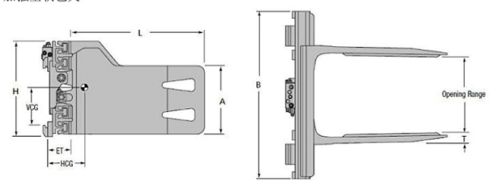

Enhanced soft encapsulation
model | carrying capacity @  (kg@mm) | Installation Class  ISO | Shoulder range of motion  ITI  (mm) | brachium L  (mm) | Arm height  C  (mm) | Arm thickness  T  (mm) | width  B  (mm) | altitude  H  (mm) | Vertical center of gravity  VCG  (mm) | Loss of load capacity  ET  (mm) | Horizontal center of gravity  HCG  (mm) | conduct oneself with dignity  (kg)
BCS-30G-01B | 3000@500 | II | 460-2330 | 460 | 1200 | 75 | 1680 | 740 | 250 | 150 | 300 | 750
BCS-30G-01C | 3000@500 | III | 460-2330 | 460 | 1200 | 75 | 1680 | 740 | 250 | 150 | 300 | 750
BCS-30G-02B | 3000@500 | II | 460-2330 | 460 | 1000 | 75 | 1680 | 740 | 250 | 150 | 300 | 730
BCS-30G-02C | 3000@500 | III | 460-2330 | 460 | 1000 | 75 | 1680 | 740 | 250 | 150 | 300 | 730
BCS-30G-03B | 3000@500 | II | 585-2000 | 460 | 1200 | 75 | 1265 | 740 | 250 | 150 | 345 | 625
BCS-30G-03C | 3000@500 | III | 585-2000 | 460 | 1200 | 75 | 1265 | 740 | 250 | 150 | 345 | 625
BCS-30G-04B | 2800@500 | II | 815-2230 | 460 | 1200 | 75 | 1330 | 740 | 250 | 150 | 345 | 730
BCS-30G-04C | 2800@500 | III | 815-2230 | 460 | 1200 | 75 | 1330 | 740 | 250 | 150 | 345 | 730
BCS-30G-05B | 3000@500 | II | 520-1870 | 460 | 1200 | 75 | 1130 | 740 | 250 | 150 | 345 | 620
BCS-30G-05C | 3000@500 | III | 520-1870 | 460 | 1200 | 75 | 1130 | 740 | 250 | 150 | 345 | 620

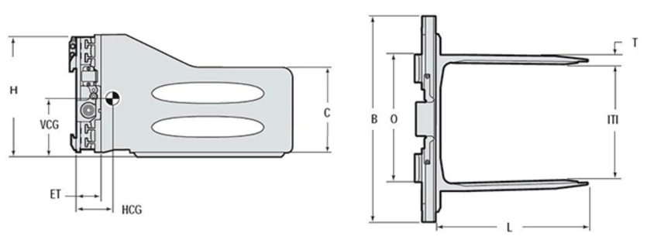

Lateral-shifting soft-clamping device
model | carrying capacity @  load center  (kg@mm) | Installation Class  ISO | Shoulder range of motion  IT1  (mm) | brachium L  (mm) | Arm height  C  (mm) | Arm thickness  T  (mm) | width  B  (mm) | altitude  H  (mm) | Vertical center of gravity  VCG  (mm) | Loss of load capacity  ET  (mm) | Horizontal center of gravity  HCG  (mm) | conduct oneself with dignity  (kg)
BCS-20D-01B | 1900@500 | II | 450-1730 | 991 | 415 | 70 | 1040 | 665 | 220 | 127 | 315 | 422
BCS-20D-01C | 1900@500 | III | 450-1730 | 991 | 415 | 70 | 1040 | 665 | 220 | 127 | 315 | 422
BCS-20D-02B | 1900@500 | II | 450-1730 | 1194 | 415 | 70 | 1040 | 665 | 220 | 127 | 401 | 465
BCS-20D-02C | 1900@500 | III | 450-1730 | 1194 | 415 | 70 | 1040 | 665 | 220 | 127 | 401 | 465
BCS-20D-03B | 1900@500 | II | 455-1735 | 685 | 415 | 70 | 1040 | 665 | 220 | 127 | 203 | 350
BCS-20D-04B | 1900@500 | II | 455-1735 | 785 | 415 | 70 | 1040 | 665 | 220 | 127 | 239 | 377
BCS-20D-05B | 1900@500 | II | 450-1730 | 915 | 415 | 70 | 1040 | 665 | 220 | 127 | 307 | 418
BCS-30D-01B | 2700@500 | II | 550-1900 | 991 | 460 | 75 | 1015 | 730 | 255 | 142 | 315 | 556
BCS-30D-01C | 2700@500 | III | 550-1900 | 991 | 460 | 75 | 1015 | 730 | 255 | 150 | 312 | 579
BCS-30D-02B | 2700@500 | II | 550-1900 | 1194 | 460 | 75 | 1015 | 730 | 255 | 142 | 396 | 624
BCS-30D-02C | 2700@500 | III | 550-1900 | 1194 | 460 | 75 | 1015 | 730 | 255 | 150 | 391 | 640
BCS-30D-03C | 2700@500 | III | 490-2300 | 990 | 460 | 75 | 1600 | 730 | 255 | 150 | 240 | 710
BCS-30D-04C | 2200@500 | III | 490-2300 | 1194 | 460 | 75 | 1600 | 730 | 255 | 150 | 240 | 730

Note:
1. The actual carrying capacity of the forklift and accessories obtained from the forklift manufacturer.
2. Forklifts require two additional sets of oil circuits.
3. Arm thickness "T" refers to the spatial dimension required for actual operation, which is different from the thickness of the actual arm plate.
4. The above types are standard types. If there are special requirements, please contact the sales personnel.

*Homsun Machinery Equipment Co., Ltd is a professional manufacture specializing in the R &D and producing of electric scissor lift , electric forklift, mobile yard ramp and motorised pallet truck high-quality hardware accessories. Established in 2016, we have over ten years of experience in the industry, dedicated to providing comprehensive solutions of carrying and lifting for all different industries.

*We are the source manufacturer and can also customize various types of forklifts according to customer needs.

*If needed, you can consult customer service.

Official website:https://www.homsunlift.com
WhatsApp/Wechat ID:+8613680275183
Email:sandy519@foxmail.com

