Special oil bucket clamp for clamp type forklift, oil bucket handling and stacking fixture, bucket holder technical parameters
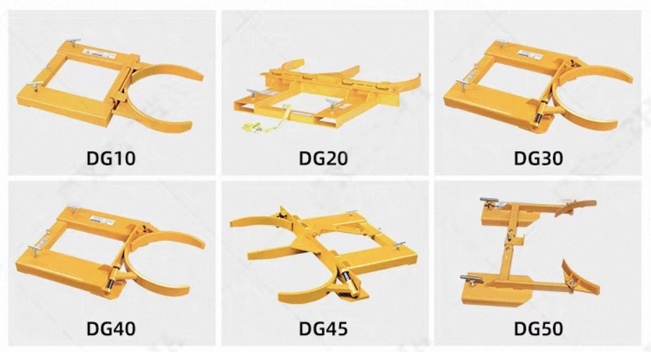

model | unit | DG10 | DG20 | DG30 | DG40 |  | DG45 | DG50
type | / | Single barrel | Double Barrel | Single barrel | Single barrel |  | Double Bucket | Single barrel
nominal load capacity | Kg | 450 | 900 | 450 | 450 |  | 900 | 300
Suitable for oil drum specifications | / | 55 gallons (φ572 × 900) |  | 30 gallons (450 × 500) or 55 gallons (φ572 × 900)
Gantry fork mouth dimensions (length × width) | mm | 140×55 | 178×55 | 140×55 | 178×55 |  | 178×55 | 138×30
Slot spacing | mm | 560 | 660 | 560 | 520 |  | 650 | 521/616
net weight | Kg | 55 | 90 | 52 | 56 |  | 88 | 20
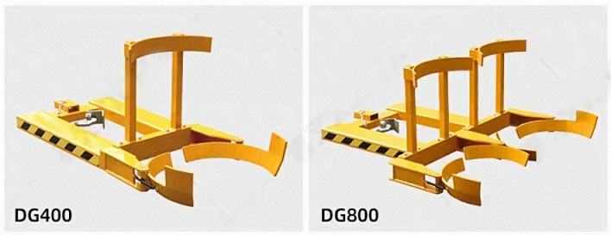

model |  | unit | DG400 |  |  | DG800
type |  | / | Single barrel |  |  | Double Bucket
load |  | Kg | 400 |  |  | 800
net weight |  | Kg | 57 |  |  | 81.7
Single-shaft sleeve dimensions |  | mm | 160*70 |  |  | 160*70
Crane sleeve length |  | mm | 755 |  |  | 755
External dimensions |  | mm | 1440*640*590 |  |  | 1440*1240*590
Outer width of the fork sleeve |  | mm | 640 |  |  | 735

*Homsun Machinery Equipment Co., Ltd is a professional manufacture specializing in the R &D and producing of electric scissor lift , electric forklift, mobile yard ramp and electric pallet jack high-quality hardware accessories. Established in 2016, we have over ten years of experience in the industry, dedicated to providing comprehensive solutions of carrying and lifting for all different industries.

*We are the source manufacturer and can also customize various types of forklifts according to customer needs.

*If needed, you can consult customer service.

Official website:https://www.homsunlift.com
WhatsApp/Wechat ID:+8613680275183
Email:sandy519@foxmail.com

Related product recommendations：
Forklift clamp type oil drum clamp
Oil Drum Flipper
Electric Drum Dumping Truck
Oil drum lifting vehicle
Oil Drum Truck

