Forklift clamp type oil drum clamp, conical oil drum handling clamp
Factory direct sales can customize various models
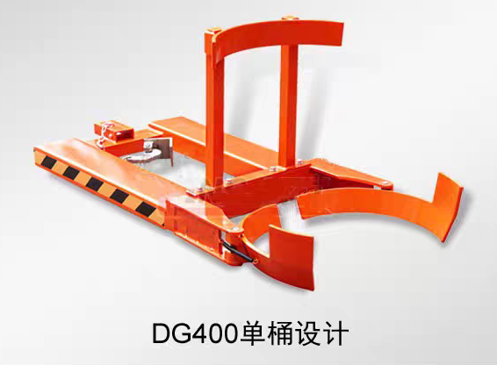

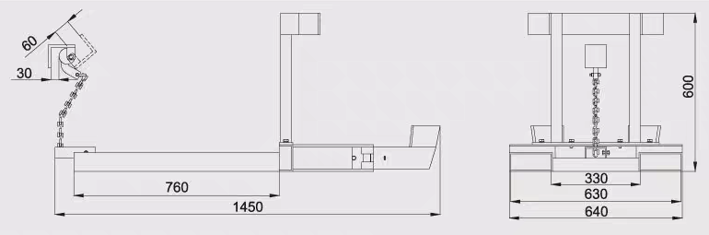
DG400 Single Barrel Main Technical Specifications
model | DG400
load （kg） | 400
net weight （kg） | 57

*******************************************************************************

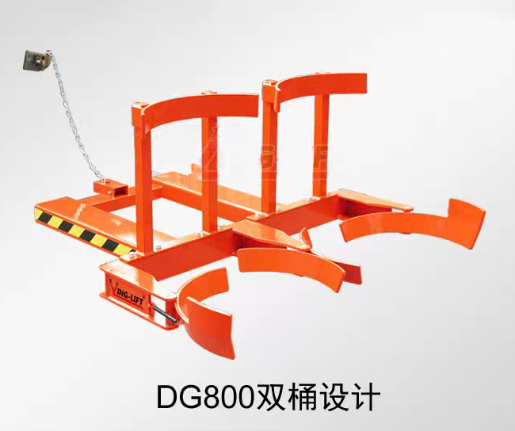
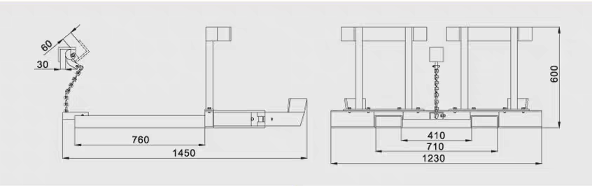

DG800 Dual Tank Main Technical Specifications
model | DG800
load （kg） | 800
net weight （kg） | 81.7

*Homsun Machinery Equipment Co., Ltd is a professional manufacture specializing in the R &D and producing of electric scissor lift , electric forklift, mobile yard ramp and pallet jack high-quality hardware accessories. Established in 2016, we have over ten years of experience in the industry, dedicated to providing comprehensive solutions of carrying and lifting for all different industries.

*We are the source manufacturer and can also customize various types of forklifts according to customer needs.

*If needed, you can consult customer service.

Official website:https://www.homsunlift.com
WhatsApp/Wechat ID:+8613680275183
Email:sandy519@foxmail.com

Related product recommendations：
Explosion proof fully electric oil drum transport vehicle
Forklift Oil Drum Clamp/Oil drum eagle beak fixture
Oil Drum Flipper/Oil Drum Dumping Attachment
Multi-functional Drum Handler
Explosion-proof Drum Dumper
Oil drum lifting vehicle
Oil Drum Truck

